BADMINTON ASSOCIATION OF INDIA

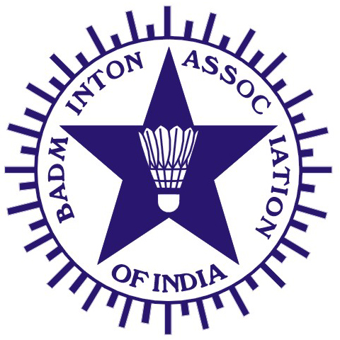
(Affiliated to the Badminton World Federation and Badminton Asia Confederation)

PRESIDENT |  | HON. TREASURER
V. K. VERMA  G-1349, Ground Floor,  Chitranjan Park (Near No. Market),  New Delhi 100019. |  | RAJINDER KALSI  Kalsi Pumps Pvt. Ltd,  B-6, Sports & Surgical Goods Complex, Kapurthala Road, Punjab 144021.
Tel.: (O) +91-11-26278243  Fax: (O) +91-11-26278830  Email: vkverma.airindia@gmail.com |  | Tel.: (O) +91-181-2651845, 2650006  Fax: (O) +91-181-2650208  Email: kalsifan@jla.vsnl.net.in

Ref.: BAI/COC/006/June2010

Shri Anil Malhotra June 18, 2010
Organizing Secretary
All India Senior Major Ranking Badminton Tournament
Malhotra Textile, Bara Bazar
Bareilly, Uttar Pradesh– 243 003.

Sub.: Appointment of Technical Officials for All India Senior Ranking Badminton
Tournament to be held at Bareilly, Uttar Pradesh between 2nd to 6th August 2010.

Dear Sir

This is to inform you that the following Technical Officials have been nominated to officiate at the forthcoming All India Senior Ranking Badminton Tournament to be held at Indoor Hall, Sports Stadium, Bareilly, Uttar Pradesh between 2nd to 6th August 2010 :

TECHNICAL OFFICIALS

1. Suryaveer Sharma (Raj)-Chief Referee 2. Arindam Chaterjee (WB)– Dy.Referee
3. Neeraj Shroff (Jar)- Grade I 4. Vinod Kuranjia (Guj)- Grade I
5. Satyendra Sharma (MP) - Grade II 6. Neeraj Kumar (Bhr) - Grade II
7. Gaurav Khanna (UP) –Grade II- Match Control

Remaining 6 Umpires shall be appointed by Shri Anil Malhotra - Organising Secretary from nearby States such as Uttar Pradesh and Bihar.

The above Technical Officials are requested to report at Bareilly, Uttar Pradesh on 1st August 2010 to Shri Anil Malhotra - Organising Secretary, on Tel.No.:0581-2571281 (OFF) / 2301504 (RES), MOBILE:09319929976 OR EMAIL: dbabareilly@gmail.com

Thanking you
Yours Sincerely

S.A.Shetty
COC-BAI

C.C. to : 1) Shri. V.K.Verma – President, BAI
2) Shri. S.Muralidharan – Chairman, COC, BAI
3) Shri. Punnaiah Choudary – Convenor-Domestic Tournaments

