BADMINTON ASSOCIATION OF INDIA

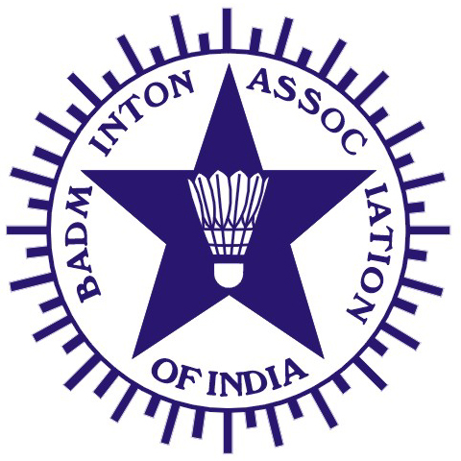
(Affiliated to the Badminton World Federation and Badminton Asia Confederation)

PRESIDENT | HON. TREASURER | HON. JT. SECRETARY
V. K. VERMA  G-1349, Ground Floor,  Chitranjan Park (Near No. Market),  New Delhi 100019. | RAJINDER KALSI  Kalsi Pumps Pvt. Ltd,  B-6, Sports & Surgical Goods Complex, Kapurthala Road, Punjab 144021. | S.A. SHETTY  401/A, MIDAS ARLEIN (Padmini CHS)  Pestom Sagar, Road No.1, Chembur  Mumbai – 400 089.
Tel.: (O) +91-11-26278243  Fax: (O) +91-11-26278830  Email: vkverma.airindia@gmail.com | Tel.: (O) +91-181-2651845, 2650006  Fax: (O) +91-181-2650208  Email: kalsifan@jla.vsnl.net.in | Telefax.: (R) +91-022-25220286  Mobile : 09821162286  Email: sashetty1@rediffmail.com
Ref.: BAI/COC/003/April2010

To
The Chairman & Members of April 16, 2010
Court Officials Committee of
Badminton Association of India

Sub.: Results of Grade I Umpires Examination held at Guwahati during Senior
National Badminton Championships.
Dear Sirs

Following are the results of the Grade I Umpires Examination held during the Senior National Badminton Championships at Guwahati during January 2010.

SUCCESSFUL CANDIDATES

- Venkat Narain 2. Anand Joshi
3. Balarina Syiem 4. Vinod Kuranjia
- Vinod Shah

THE FOLLOWING CANDIDATES HAVE PASSED THEIR THEORY EXAMINATION AND HAVE FAILED IN PRACTICAL EXAMINATION.

1. Gaurav Khanna 2. Dr.Satyendra Sharma
3. Sanjay Sonawane 4. Madhavan
5. Milind Deshmukh 6. Dinesh

Yours Sincerely
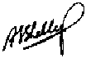
S.A. Shetty
COC – BAI

C.C. to : Mr. V.K.Verma – President, BAI
Mr. S.Muralidharan – Chairman –COC
Mr. Girish Natu – COC –BAI
Mr.Punnaiah Choudary – Convenor-Domestic Tournaments

