BADMINTON ASSOCIATION OF INDIA

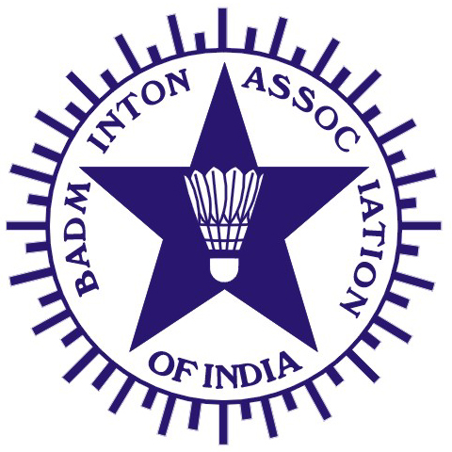
(Affiliated to the Badminton World Federation and Badminton Asia Confederation)

PRESIDENT | HON. TREASURER | HON. GENERAL SECRETARY
V. K. VERMA  Director General , OCCG-2010  9th Floor NDMC Building , Phase-II  Opp: Jantar Mantar ,Jai Singh Road  New Delhi-110 001  Mobile: 09820408827/09999514600  Email: vkverma.airindia@gmail.com | RAJINDER KALSI  Kalsi Pumps Pvt. Ltd,  B-6, Sports & Surgical Goods Complex, Kapurthala Road, Punjab 144021.  Tel.: (O) +91-181-2651845, 2650006  Fax: (O) +91-181-2650208  Email: kalsifan@jla.vsnl.net.in | DR. VIJAI SINHA  F-3B, River Bank Colony  Lucknow - 226018  Uttar Pradesh.  Phone .: 0522 - 2615924  Mobile : 09839014455  Email: drvijaisinha@yahoo.co.in
Ref.: BAI/COC/002/December2010

Shri Punnaiah Choudary K.Ch December 10, 2010
Organizing Secretary

India Open Grand Prix 2010
Hyderabad, India.

Reg: Nomination of Technical Officials for forthcoming India Open Grand Prix 2010
Tournament to be held at Hyderabad from 14th to 19th December 2010.
Dear Sir

The following Technical officials have been nominated to conduct of above mentioned India Open Grand Prix 2010 Tournament to be held at Hyderabad between 14th to 19th December 2010.
Indian International Umpires
1. Moses Manoharan (TN) 2. Sudhir Ghate (MAH)
3.Dhananjay (Uday) Sane (MAH) 4. Rajeet Srivastava (UP)
Grade I Umpires
1. Brijesh Gour (MAH) 2. Sharad Varma (Guj) 3.D.Jayachandra (AP)
4. Rajiv Mehta - Match Control
The above Technical Officials are requested to confirm their availability to the undersigned immediately on receipt of this letter and they are required to arrive at Hyderabad, Andhra Pradesh on 13th December 2010 and report to Shri Punnaiah Choudary - Organizing Secretary, on Mob: 09440159044, or email : kcpchoudary@yahoo.com

Yours Sincerely

S.A.Shetty
COC-BAI

C.C. to : 1) Shri. V.K.Verma – President, BAI
2) Dr.Vijai Sinha – Hon. Gen. Secretary, BAI
3) Shri. S.Muralidharan – Chairman, COC, BAI
4) Shri. Punnaiah Choudary – Convenor-Domestic Tournaments

