BADMINTON ASSOCIATION OF INDIA

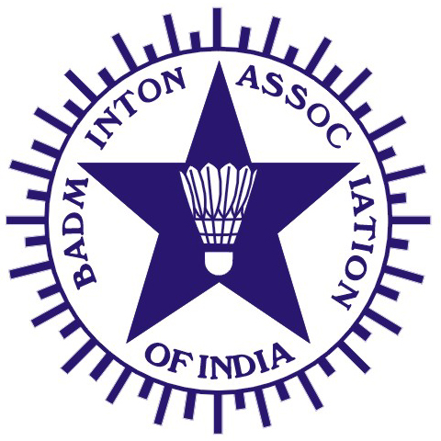
(Affiliated to the Badminton World Federation and Badminton Asia Confederation)

PRESIDENT | HON. TREASURER | HON. GENERAL SECRETARY
V. K. VERMA  Director General , OCCG-2010  9th Floor NDMC Building , Phase-II  Opp: Jantar Mantar ,Jai Singh Road  New Delhi-110 001  Mobile: 09820408827/09999514600  Email: vkverma.airindia@gmail.com | RAJINDER KALSI  Kalsi Pumps Pvt. Ltd,  B-6, Sports & Surgical Goods Complex, Kapurthala Road, Punjab 144021.  Tel.: (O) +91-181-2651845, 2650006  Fax: (O) +91-181-2650208  Email: kalsifan@jla.vsnl.net.in | DR. VIJAI SINHA  F-3B, River Bank Colony  Lucknow - 226018  Uttar Pradesh.  Phone .: 0522 - 2615924  Mobile : 09839014455  Email: drvijaisinha@yahoo.co.in
Ref.: BAI/COC/001/December2010

Shri U.Vimal Kumar December 9, 2010
Organizing Secretary
TATA Open India International Challenge
Mumbai.
Reg: Nomination of Technical Officials for forth coming TATA Open International Challenge
Tournament to be held at Mumbai from 22nd to 25th December 2010.
Dear Sir

The following Technical officials have been nominated to conduct of above mentioned TATA Open International Challenge Tournament from 22nd to 25th December 2010.

Indian International Umpires
1. Vinod Badkundri (MAH) 2. Vrushali Upadhyay (MAH)
3. F.F.Baria (Guj) 4. Fine C. Dathan (Ker)

Grade I Umpires
1. Manjusha Sahasrabudhe (MAH) 2. Shashank Kulkarni (MAH)
3. Vivek Saraf (MAH) 4. Melvin Minoy (Ker)
5. C.R.Rajeev – (KER) 6. Rajiv Mehta - Match Control

The above Technical Officials are requested to confirm their availability to the undersigned within 7 days of receipt of this letter and they are required to arrive at Mumbai, Maharashtra on 21st December 2010 and report to Shri U.Vimal Kumar Organizing Secretary, on Mob: 09945113699, or email uvimalkumar@hotmail.com.

Yours Sincerely

S.A.Shetty
COC-BAI

C.C. to : 1) Shri. V.K.Verma – President, BAI
2) Dr.Vijai Sinha – Hon. Gen. Secretary, BAI
3) Shri. S.Muralidharan – Chairman, COC, BAI
4) Shri. Punnaiah Choudary – Convenor-Domestic Tournaments

