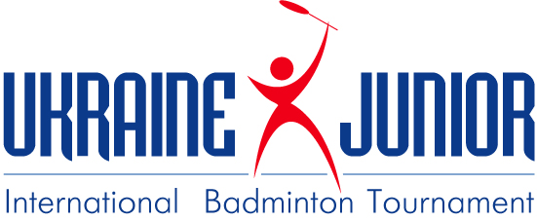

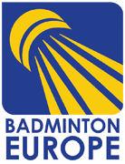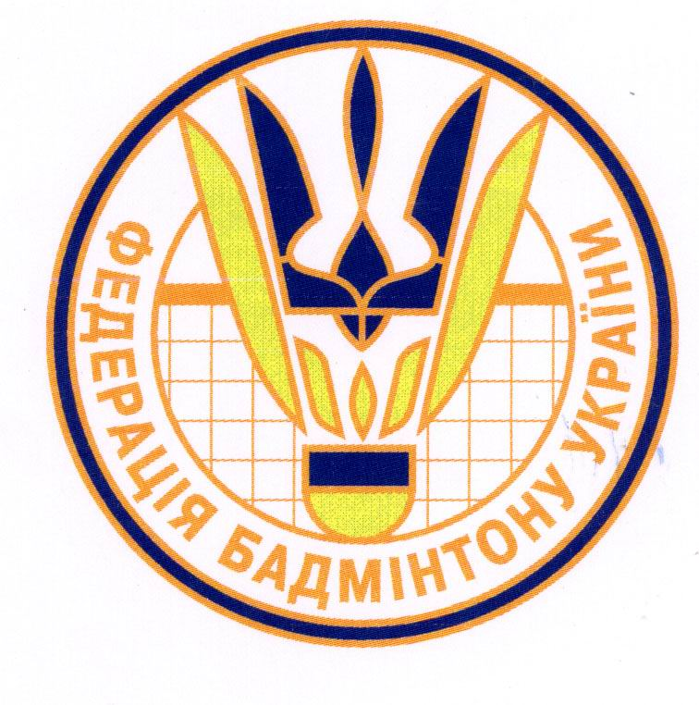

Ukraine Junior International Tournament 2012

U19 part of the Badminton Europe Junior Circuit 2012/2013

29 August -01 September 2012

sanctioned by Badminton World Federation

presented & organized by Badminton Federation of the Ukraine

prize money 2000$

Closing Date: 08 August 2012
Entries from BWF members associations exclusively will be accepted

Ukraine Junior International Tournament 2012

Venue
SK “ Meteor”
Makarova str., 27A
49047 Dnіpropetrovsk,
Ukraine
Tel: +380567876363, +380675601543
Fax: +380567876363
E-mail: s_bendin@meteor.dp.ua

SCHEDULE
Wednesday 29th August 2012 from 11:00 (team managers meeting) 13:00 (beginning tournament)

Thursday 30th August 2012 from 10:00
Friday 31th August 2012 from 10:00
Saturday 01th September 2012 finals from 11:00
Time schedule can be subject to changes.

GENERAL
The tournament will be played in accordance with the Laws of Badminton, BWF’s General Competition Regulations and Badminton Europe’s Junior Circuit Regulations. In the event of any dispute, the Referee’s decision shall be final.

ELIGIBILITY
- Ukrainian Badminton license for the Ukrainian players.
- Foreign players have to be members of an association affiliated to the BWF.
- According to BWF rules
U19 boys/girls: singles, doubles and mixed.
ENTRIES
Entries must be done in order of strength.
96 in singles, 48 in men’s and women’s doubles and 64 in mixed doubles will be accepted.
If the amount of entries exceeds the maximum amount selection of entries shall be done by BADMINTON EUROPE.
According to Badminton Europe Junior Circuit 2012/2013 Regulations point 2.3, it is required that every event has at least 8 competitors (i.e. actual competitors, not merely entries),
If the required number of competitors is not met, this particular event shall not count towards any ranking.

Entries Should be senT to
1. Vladyslav Druzhchenko
vdruzhchenko@yahoo.com
2. Bendin Sergej
s_bendin@meteor.dp.ua
Please send entries and other details not later than 08 August 2012.

ENTRY FEES Singles: 20 € per player
Doubles & Mixed: 15 € per player / 30 € per pair

PRIZE MONEY

 | MS | WS | MD | WD | XD
Winner | 250 | 250 | 300 | 300 | 300
Runner-up | 150 | 150 | 100 | 100 | 100

Clothing and Advertisement
We refer to the BWF’s General Competition Regulations reg. 19-23.

REFEREE : Lajos Csanda (Hungary)

SHUTTLECOCKS : Forza

NUMBER OF COURTS: 4

TRANSPORT City of Dnіpropetrovsk has an airport with good connections with some European countries. You can also fly to Kiev and then get train or bus to our city. Distance between Kiev and Dnіpropetrovsk – 500 km. Transfer between Dnіpropetrovsk airport, railway station and the hotels, and also between the hotels and the venue will be provided by the organizer.Flight information must be sent no later than 7 days before the first day of tournament

VISA : If necessary,Visa application must be sent to
s_bendin@meteor.dp.ua no later than 30 days before the tournament starts.

AccoMModation :

“Sverdlovsk” hotel
6 Sverdlova str.,
Dnipropetrovsk, 49101,
Ukraine

double standard( 2 person)- 45 Euro per room
single standard ( 1 person)- 35 Euro per room
“Luxury” (limited, 1-2 person) - 60 Euro per room

All prices included breakfast.

“Yuzhnaya” hostel
174 Rabochaya str.,
Dnipropetrovsk Ukraine

double ( 2 person) - 25 Euro per room
triple ( 3 person) - 30 Euro per room
( WC and bath on the floor)

All prices included breakfast.
(additional fee for booking – 50% of the one day rate)

All rezervation apply must be sent to organizers club:
s_bendin@meteor.dp.ua. We don’t have
responsibility on transport for
teams who will not accomodate in official hotels.

PAYMENTS all payments (accommodation, entry fees etc.) must
be paid at accreditation in cash (no credit card
accepted).

INSURANCE All participants are under their own responsibility

Tournament web page
www.meteor.dp.ua

BE JUNIOR CIRCUIT In 2012/2013, Ukraine Junior International Tournament U19 is the official BADMINTON EUROPE JUNIOR CIRCUIT 2012/2013 organized by the Badminton Europe. Only the U19 category is the Badminton Europe Junior Circuit.
More details you can find on the official Web-Site of BE on www.badmintoneurope.com

Entry form Ukraine Junior International Tournament 2012
part of the European Junior Badminton Circuit 2012/2013

Form to be returned latest by 08 August 2012

National Association:

Contact person: E-mail:

Phone number: Fax number:

Please type or write clearly in BLOCK CAPITALS.
Entries must be shown in order of strength

 | Family name | First name | Date of birth | BWF №
Men’s singles
1
2
3
4
5
6
7
8

Women’s singles
1
2
3
4
5
6
7
8

Entry form Ukraine Junior International Tournament 2012
part of the European Junior Badminton Circuit 2012/2013 (continued)
Form to be returned latest by 08 August 2012
 | Family name | First name | Date of birth | BWF №
Men’s doubles
1
2
3
4
5
Women’s doubles
1
2
3
4
5
Mixed doubles
1
2
3
4
5

TRAVEL INFORMATION

It is important that you supply your arrival and departure information to:
__s_bendin@meteor.dp.ua__ __vdruzhchenko@mail.yahoo.com

Without this information ‘pick-up’ transportation can not be arranged for your team.

Team Name:
___________________________________________________________

Arrival details

Arrival Date

Airline/train
Flight/train number
Arrival time
Number of people

Departure details

Departure Date

Airline/train
Flight/train number
Departure time
Number of people

Please send travel information’s not later than a week before arrival

