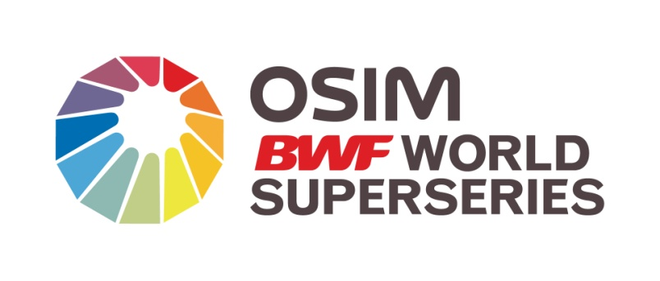
TICKETING
BOOK MY SHOW is the official ticketing agency for the Yonex Sunrise Indian Open. The Tickets can be booked through:
- the website www.bookmyshow.com,
- BMS call centre(39895050) and
- 10 designated retail outlets across Delhi NCR
- Ticket Box office opposite Kendriya Vidyalaya Playground/ Parking, Sadiq Nagar near Siri fort Sports Complex(operational from 26th April 2011)
TICKET PRICES
The Ticket prices will range from:
- Rs 200 to 300 during the preliminary rounds
- Rs 500 to 1000 during the QF/ SF / Finals Stage
There will be a special category for students ranging from Rs 100 to 200 during Preliminary rounds and Rs 400 for QF/SF/Finals

