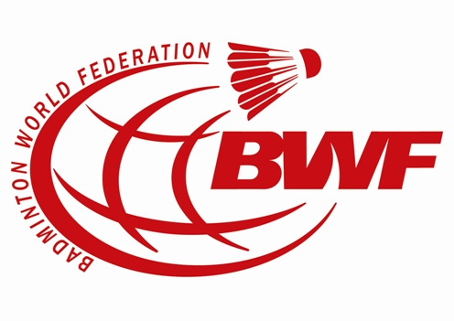
BWF REFEREE TRAINING WORKSHOP
5 – 6 OCTOBER 2012
APPLICATION FORM

Name:

Country / Member Association:

Continent:

Position :

Date of Birth:

Address:

Mobile No:

Home Phone No:

Email:

Experience: (Please state your experience i.e refereeing, umpiring, organization and etc)

Member Association Recommendations:

Name:___________________ Position: __________________

Remarks from Continental Confederation (If any):

Name:___________________ Position: __________________

Please complete and return to BWF Secretariat not later than 15 July 2012:

Ms. Noridah Jamil
Email: j.noridah@bwfbadminton.org
Fax: +603 – 2143 7155

